What are Thickened Nails?  Thickened nails are also known as Onychauxis nails. This is an abnormal thickening of the nail which is quite a common condition. The big toenail is the most commonly affected. Cutting the nail becomes very difficult and pressure from shoes can cause this condition to become painful.  What causes it?  - A major trauma or repeated pressure from shoes on long nails.  - Fungal infection of the nails or skin diseases.  - Poor circulation, particularly in elderly people.  - Psoriasis, eczema and a number of other systematic diseases can affect the toenails. |  |  | Where are we?  Address  Covering Sunderland, Washington, Seaham &  surrounding areas, South Shields, Boldon, Cleadon, Whitburn, Houghton le Spring and surrounding areas, Hetton, Penshaw, Shiney Row,  Wardley in Gateshead, etc.  Contact Us  Phone: 0191 5140817 or 07935039600  Email: themobilefootclinic@yahoo.com  Web: www.themobilefootclinic.net  themobilefootclinicsunderland  twitter.com/mobilefoot  themobilefootclinicsunderland |  |  |  | 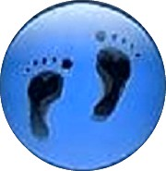  Thickened Nails  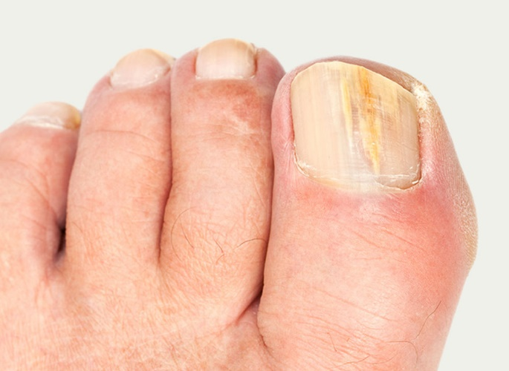  www.themobilefootclinic.net
What will happen if I leave it untreated?  Left untreated thickened nails can start to curl and can turn a yellowy, brown colour.  A professional opinion from a Podiatrist should be sought to ensure that there are no underlying problems which have caused the nails to thicken.  What can help?  - Correctly trimming your nails. Cut them straight across and do not round the corners of the nail.  - Wear good fitting shoes with ample room for toes and nails.  - Try to avoid shoes with a small toe box such as pointed shoes.  - Seek help from a professional such as a Podiatrist if you are experiencing problems with your feet. |  |  |  | What are the treatment options?  It is essential that thickened nails are managed with routine chiropody treatment.  A podiatrist can reduce the thickness of the nails and keep them to a reasonable length.  If the nails have become thickened due to a fungal infection your Poditrist may recommend the prescription of oral or topical anti-fungal medication.  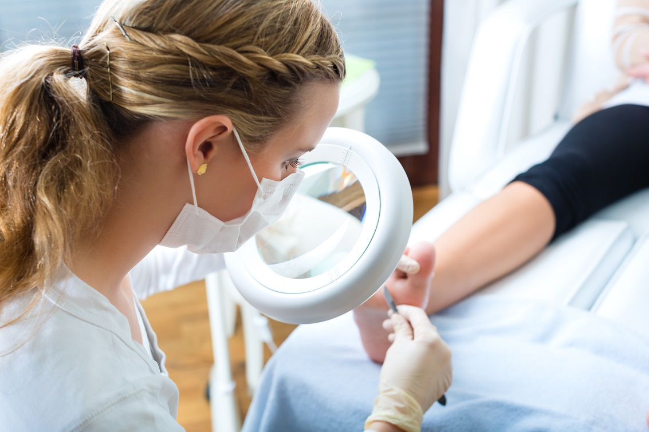  www.themobilefootclinic.net |  |  | What is the Mobile Foot Clinic?  The Mobile Foot Clinic offers a mobile service to the public providing a range of foot care treatments. Following treatment a gentle foot massage is carried out. Where appropriate, clients are advised on ways to prevent future foot problems.  The Mobile Foot Clinic has been established since 2007, covering Sunderland, Tyne and Wear and surrounding areas.  A qualified Podiatrist, Lynn Ward runs and owns The Mobile Foot Clinic.  Find out more via my website:  www.themobilefootclinic.net

