What is Athlete’s Foot?  Athlete’s foot is a common fungal skin infection commonly found between the toes and on the sole of the foot. The skin becomes itchy which can cause real discomfort.  Athlete’s foot can cause the skin to flake and peel. As the skin is itchy you are more likely to scratch which can cause the skin to split. In severe cases a secondary infection can occur where the skin has split.  What causes it?  Fungal infections thrive in dark, warm and moist environments. Inside the shoe is the perfect environment for an infection to develop.  Athlete’s foot can be spread by direct contact or by touching a surface that has been in contact with the infected area.  Gyms and changing rooms are often cited as places for the infection to spread due to the warm moist environment. |  |  |  |  |  |  | 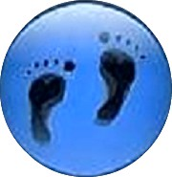  Athlete’s Foot  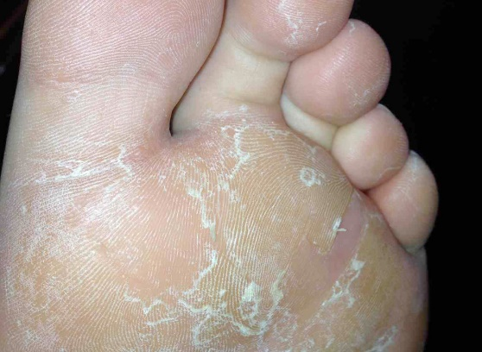  www.themobilefootclinic.net
  Where are we?
  Address
  Covering Sunderland, Washington, Seaham &
  surrounding areas, South Shields, Boldon, Cleadon, Whitburn, Houghton le Spring and surrounding areas, Hetton, Penshaw, Shiney Row,
  Wardley in Gateshead, etc.
  Contact Us
  Phone: 0191 5140817 or 07935039600
  Email: themobilefootclinic@yahoo.com
  Web: www.themobilefootclinic.net
  
  themobilefootclinicsunderland
  
  twitter.com/mobilefoot
  
  themobilefootclinicsunderland
What will happen if I leave it untreated?  Athlete’s foot can spread to the surrounding areas and the nails if left untreated. In severe cases, a fungal nail infection can develop. A fungal nail infection can be uncomfortable and causes the nail to become discoloured and have a strong odour.  What can help?  After washing your feet, dry them thoroughly paying particular attention to the area between the toes.  Wearing cotton socks and shoes that allow your feet to breathe can prevent an infection developing. In addition it is always recommended that you wear fresh socks and / or hosiery every day.  If you do have an infection it is important not to share towels and socks with others. Towels and socks should be washed regularly to get rid of any fungal residue. Wearing flip flops in the gym or changing room can also halt the spread of infection. |  |  |  | What are the treatment options?  There are many off the shelf treatments for Athlete’s foot. Some treatments only require an application every 3 months. It is advisable to read the instructions very carefully before beginning treatment. You may need to continue with treatment even if your symptoms have subsided.  It is also very important to wash socks, hosiery, bed sheets and towels on a hot wash on the day of treatment to reduce the chance of re-infection.  As with all conditions of the foot, it is advisable to seek advice from a Podiatrist if the symptoms persist or are particularly uncomfortable.  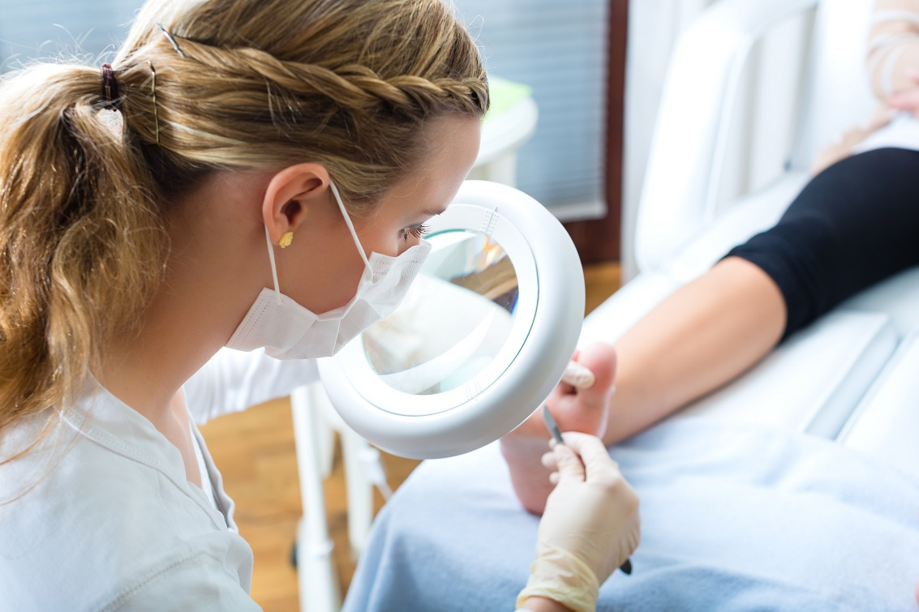  www.themobilefootclinic.net |  |  | What is the Mobile Foot Clinic?  The Mobile Foot Clinic offers a mobile service to the public providing a range of foot care treatments. Following treatment a gentle foot massage is carried out. Where appropriate, clients are advised on ways to prevent future foot problems.  The Mobile Foot Clinic has been established since 2007, covering Sunderland, Tyne and Wear and surrounding areas.  A qualified Podiatrist, Lynn Ward runs and owns The Mobile Foot Clinic.  Find out more via my website:  www.themobilefootclinic.net

