What is Arthritis?  Arthritis is a broad term for a number of conditions that destroy the workings of a normal joint. Arthritis can occur in many parts of the body and you will often hear people says it affects the joints. Arthritis can also occur in the feet and in many people, it does not cause any symptoms.  What causes it?  There are many types of arthritis with a number of different causes. The most common type of arthritis is Osteo Arthritis which is a result of general wear and tear to the cartilage in a joint. This often causes pain, redness and swelling in the joint. Degeneration of the cartilage at the base of the big toe can often occur. Bony spurs can then develop which causes pain and decreased motion of the joint.  Injury to a joint can also cause arthritis. Unfortunately, arthritis can occur even if the injury was treated at the time of the injury.  Rheumatoid arthritis is caused by irritation to the joint lining and is an inflammatory condition. |  |  | Where are we?  Address  Covering Sunderland, Washington, Seaham &  surrounding areas, South Shields, Boldon, Cleadon, Whitburn, Houghton le Spring and surrounding areas, Hetton, Penshaw, Shiney Row,  Wardley in Gateshead, etc.  Contact Us  Phone: 0191 5140817 or 07935039600  Email: themobilefootclinic@yahoo.com  Web: www.themobilefootclinic.net  themobilefootclinicsunderland  twitter.com/mobilefoot  themobilefootclinicsunderland |  |  |  | 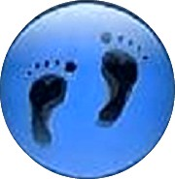  Arthritis  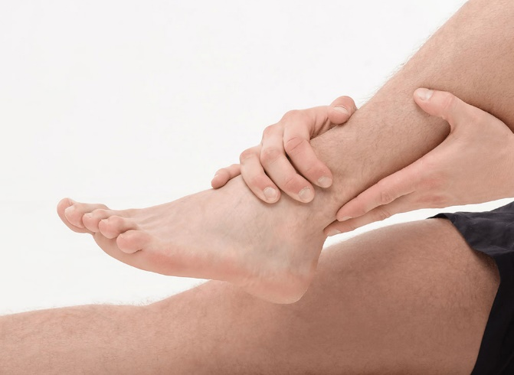  www.themobilefootclinic.net
What will happen if I leave it?  Arthritis can start as a dull ache or a nagging pain. If left untreated it can become worse and in some cases, can reduce your mobility. Due to the pain you may find that you are unable to carry out your everyday activities without pain.  What can help?  Wearing a comfortable and supportive shoe can help to reduce the pain that arthritis causes in the feet.  High heels should be avoided due to the extra pressure that they cause to the balls of the feet.  Your Podiatrist can advise the type of shoes to look for when shoe shopping.  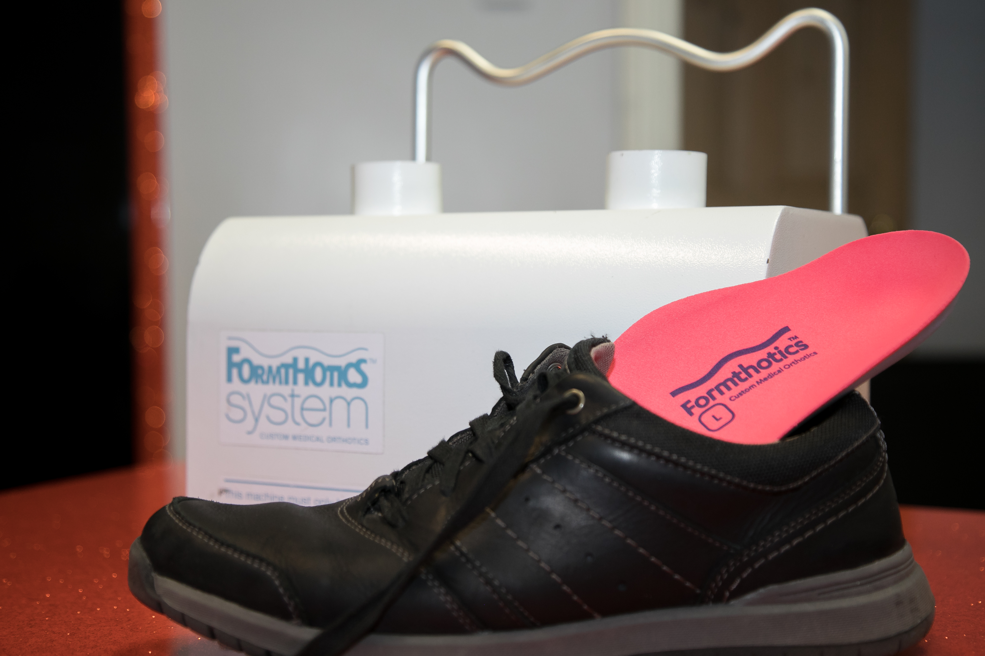 |  |  |  | What are the treatment options?  Orthotics may be prescribed by your Podiatrist to redistribute the weight and relieve pressure on the parts of the foot affected by arthritis. If there is a gait or biomechanical abnormality an orthotic device can help to correct these abnormalities.  Your Podiatrist may also prescribe some exercises which will keep the joints mobile. The exercises prescribed could be something as simple as wiggling your toes.  NSAID’s such as Ibuprofen can help to reduce the pain and joint inflammation.  www.themobilefootclinic.net |  |  | What is the Mobile Foot Clinic?  The Mobile Foot Clinic offers a mobile service to the public providing a range of foot care treatments. Following treatment a gentle foot massage is carried out. Where appropriate, clients are advised on ways to prevent future foot problems.  The Mobile Foot Clinic has been established since 2007, covering Sunderland, Tyne and Wear and surrounding areas.  A qualified Podiatrist, Lynn Ward runs and owns The Mobile Foot Clinic.  Find out more via my website:  www.themobilefootclinic.net

